# id:14-28-14

- Question i
  - The data seems to be along a curve when viewed primarily from the first data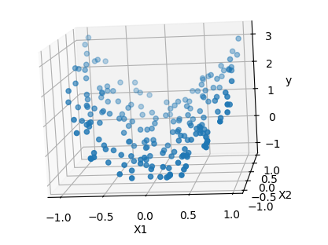. It appears much closer to a linear solution when viewed from X2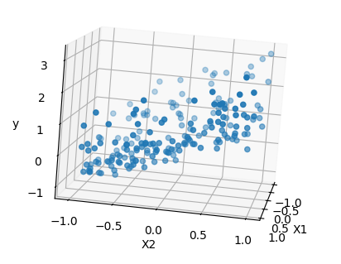
  - 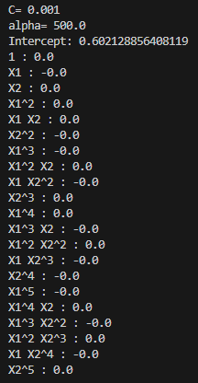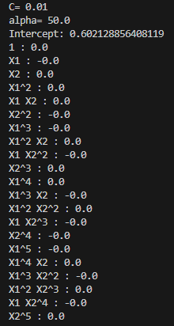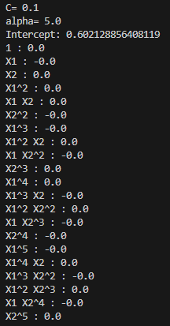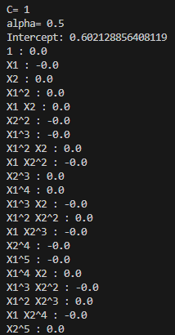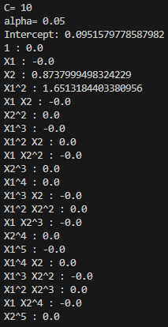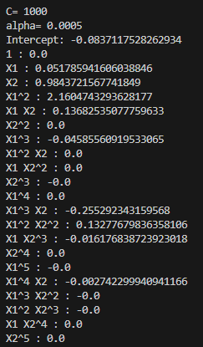
As the C value increased, and the alpha value lowered, more coefficients came into effect, With C values at or below 1, we can see that it is solely reliant on the intercept, with no non-zero coefficients. Whereas the higher C values have a C value much closer to 0, but use a lot more coefficients, this is great for our model, but may result in overfitting.
  - 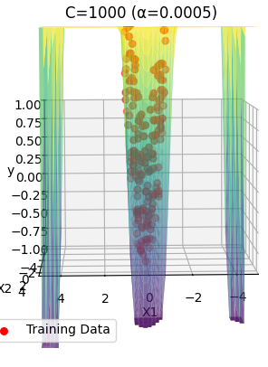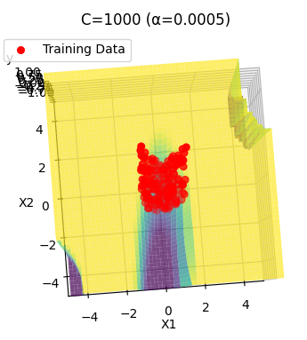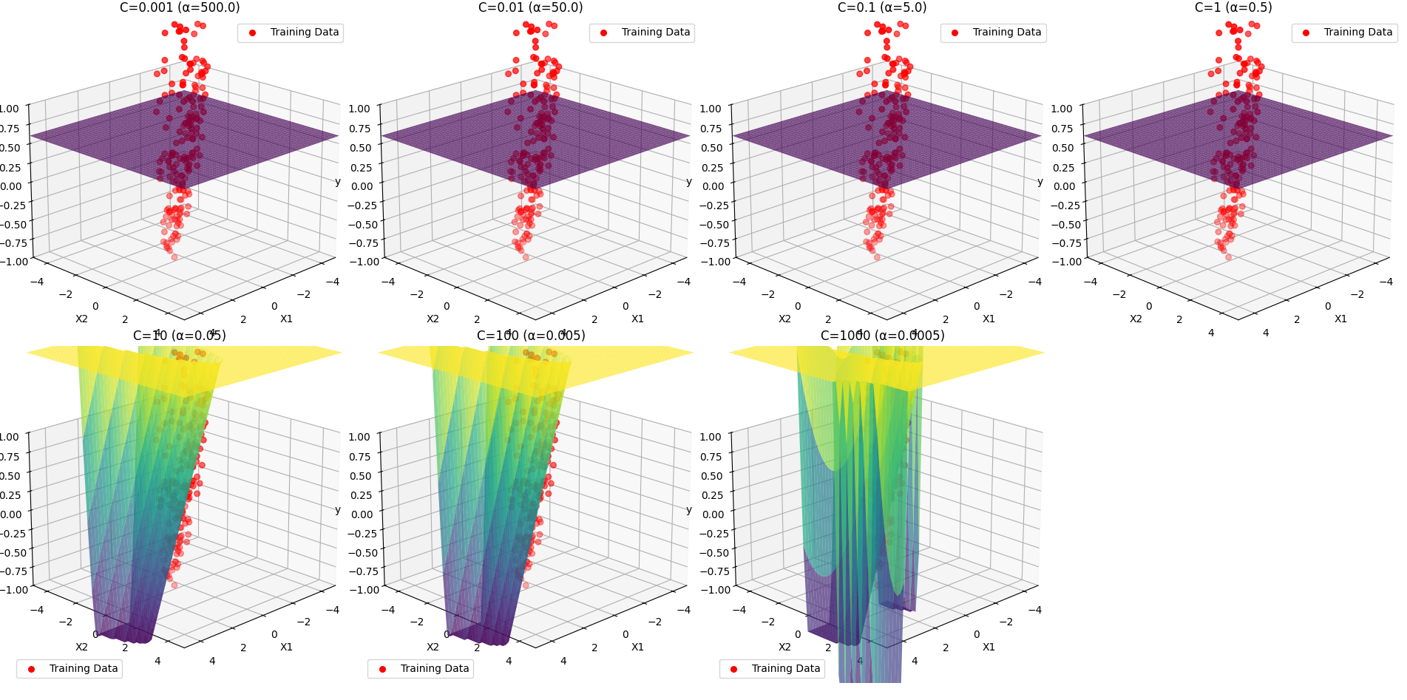While the surface plots are hard to read at higher c values, we can see that they are very closely accurate to the training data, and become more jagged and chaotic as it goes on.
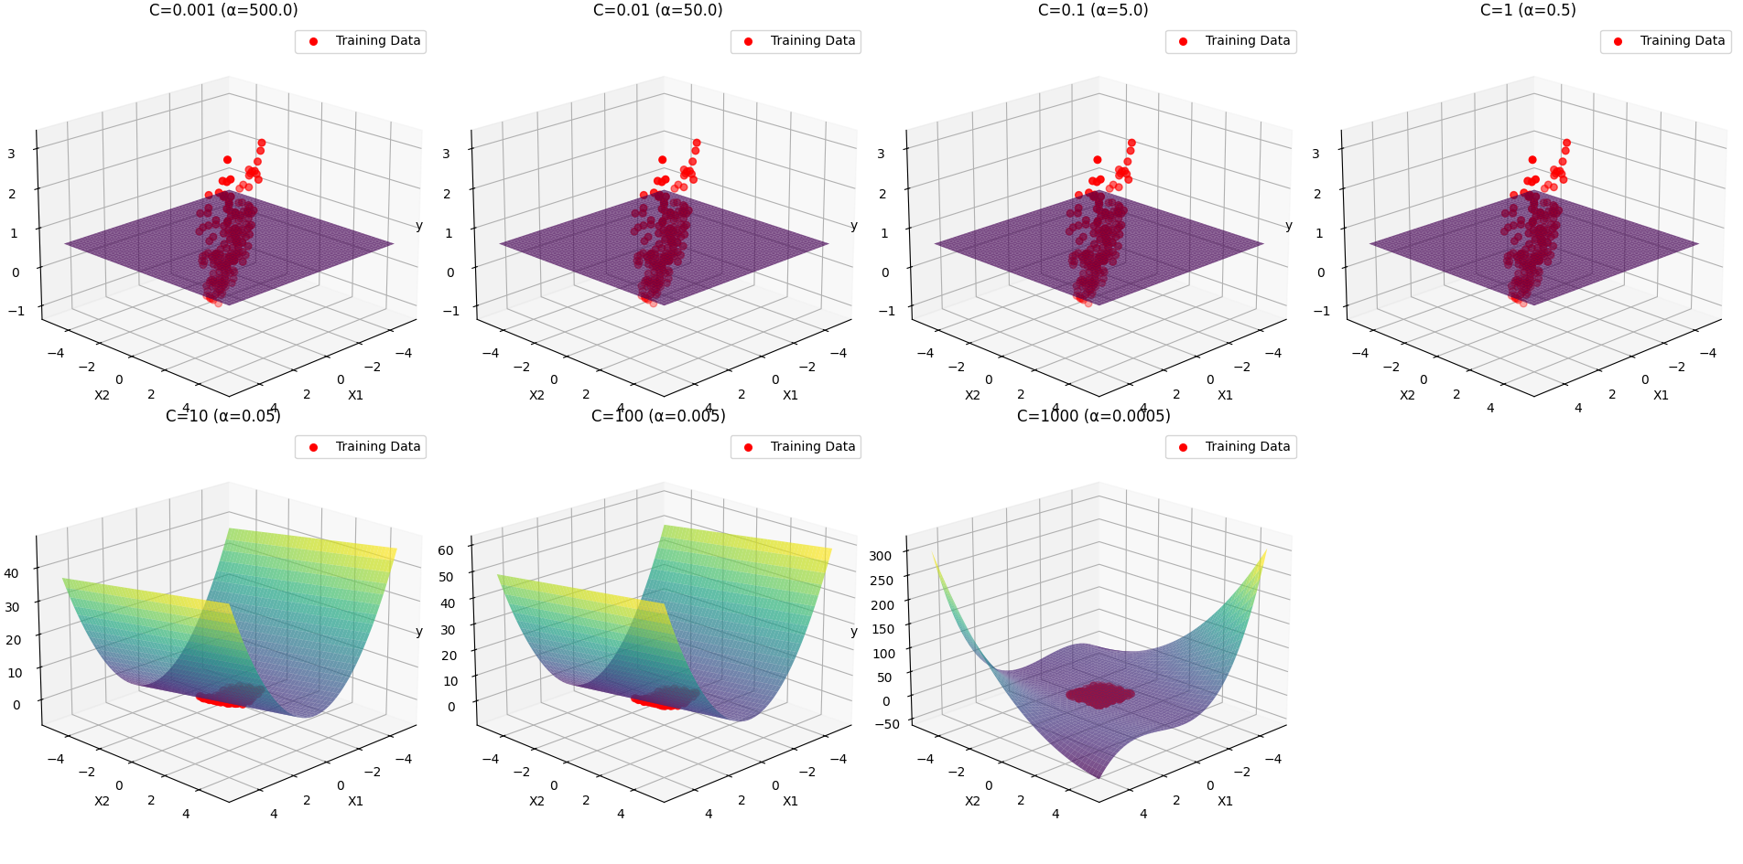When the graphs are unrestricted and zoomed out we are able to see that they take on much more complex shapes, and that their y values are a lot higher than their X1 and X2 values, this is a clear sign of overfitting with high values of C
  - By looking at the graphs in question c we can clearly see the y values of the graphs shoot up drastically with high c values(such as 1000), this is not very likely to be accurate to any data outside of what we have received, but is highly accurate to the data we do have, a clear case of overfitting. Inversly, low values of C show a completely flat plane with an attrocious accuracy to the data given, this is a clear case of underfitting, finding a balance to te C value is vital to get a well fitted model
  - 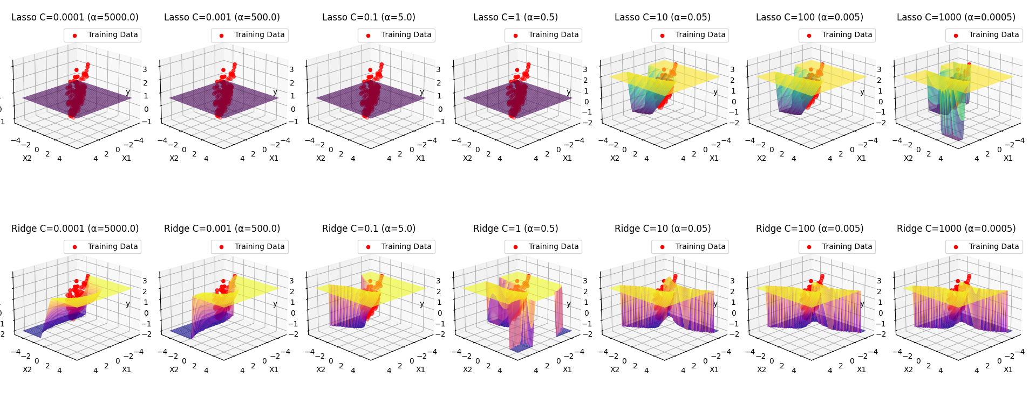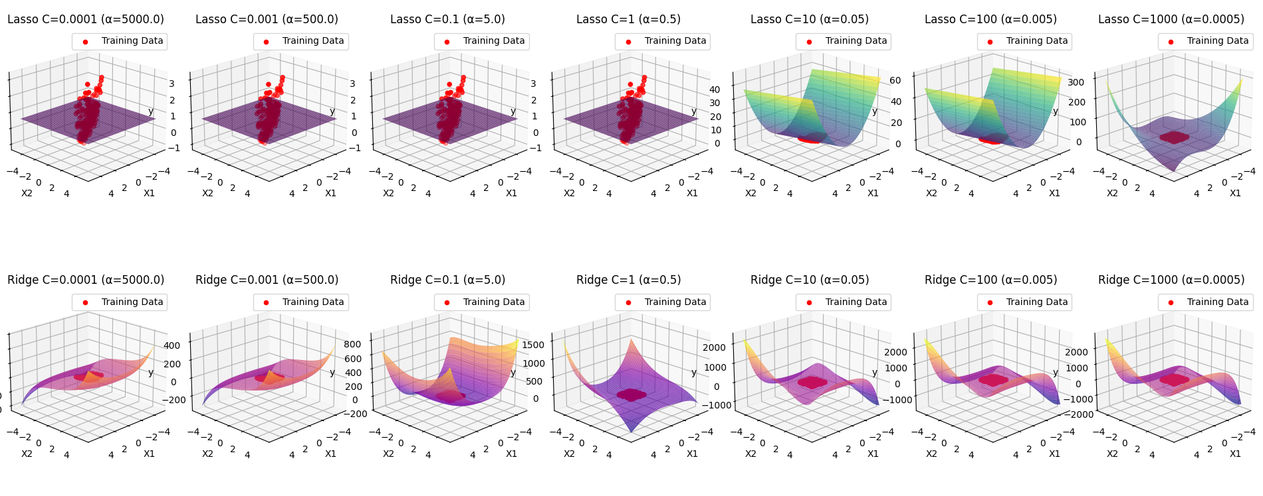
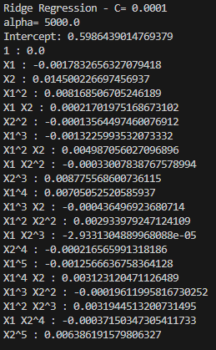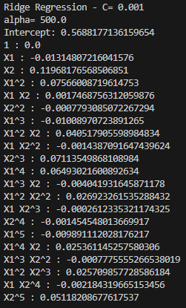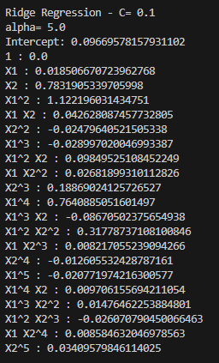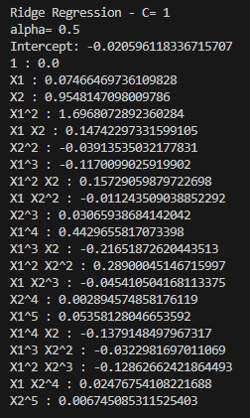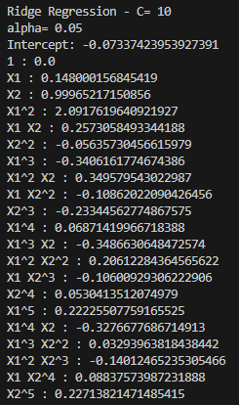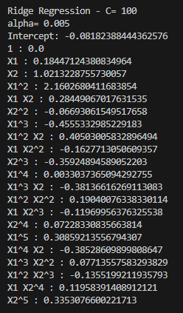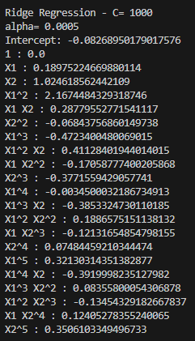
The biggest difference between the coefficients of the Ridge model is how there are none at 0, many get very very close (e.g. -0.0007) but none ever reach 0
The most noticable difference on the graphs is how the low levels of C still have complex suitable forms, fitting the data with surprising accuracy and having a more complex model when seen in whole. Another feature is how the lower c values cause major shift, while the higher ones seem to fall into line, the opposite of the lasso models.
- Cross validation to select C
  - 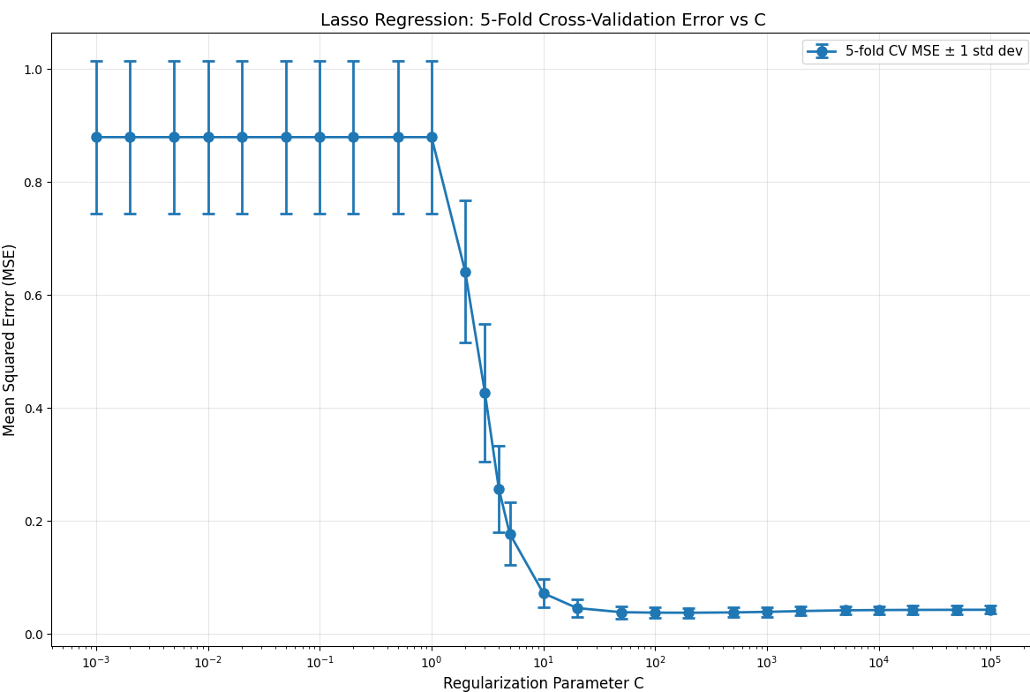A much larger range was tested for this, I decided to use a larger, more precise range as the code ran much faster, and the upward trend after the drop was very hard to see without continuing the graph much
  - 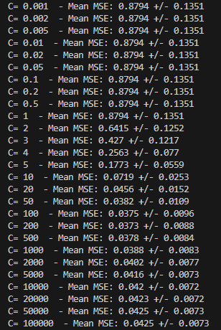 I would recommend C=200, it has the lowest MSE and has a decently low standard deviation, and since it is relatively low C value on the graph, it also means that it shouldn’t have much risk of overfitting
  - 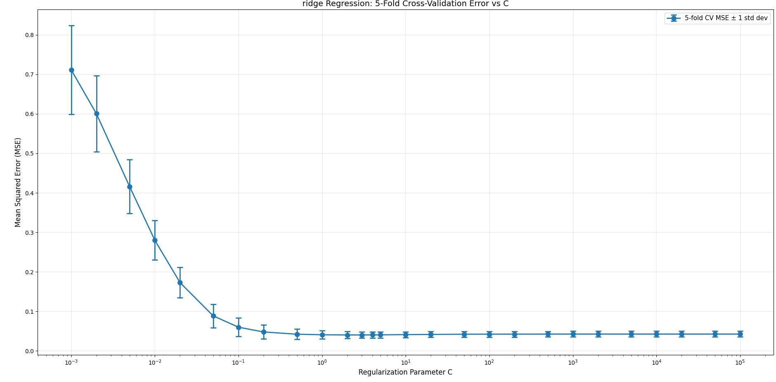The graph of Ridge looks very different to the graph of the lasso model, reaching an optimal result at much lower values than the lasso model (C=2 vs C=200),.
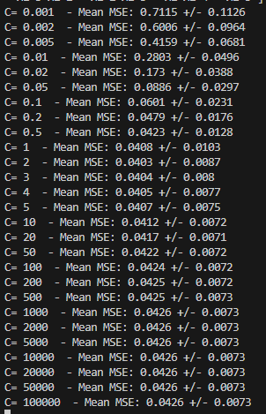The best possible C for Ridge seems to be at 2, which has the lowest MSE and one of the lowest standard deviation, while also being very very early in the possible C values. This performance is lower than Lasso’s performance(0.0403 vs 0.0373), this shows that ridge may be less optimal for this dataset at its limits, but its lower C value does suggest that it is better at managing datasets that are dependent on multiple polynomial features, while lasso could be better with datasets without a large amount of polynomial features

